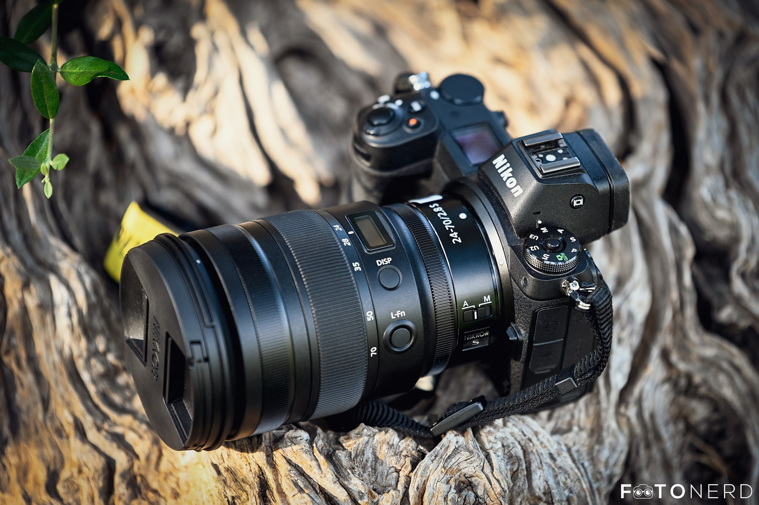

Nikon Z9 Mirrorless Camera

Professional Product Details & Features (A4 Page)

Introduction
The Nikon Z9 is Nikon's flagship professional full-frame mirrorless camera, designed to deliver exceptional performance for photographers and filmmakers. Introduced for professionals, the Z9 combines advanced imaging technology, lightning-fast speed, intelligent autofocus, and outstanding video capabilities into a rugged, weather-sealed body. It is ideal for sports, wildlife, fashion, wedding, commercial, journalism, and cinematic productions where reliability and image quality are critical.

Professional Features

1. 45.7 Megapixel Full-Frame Stacked CMOS Sensor
The Nikon Z9 is equipped with a 45.7 MP full-frame stacked CMOS sensor, capable of producing ultra-high-resolution images with incredible detail, natural colors, and excellent dynamic range. The sensor performs exceptionally well in both daylight and low-light conditions while minimizing image noise.

2. EXPEED 7 Image Processor
Powered by Nikon's latest EXPEED 7 processor, the camera delivers lightning-fast image processing, improved autofocus performance, reduced rolling shutter, faster burst shooting, and superior video recording capabilities.

3. Advanced AI Autofocus System
The Nikon Z9 features an intelligent 493-point Hybrid Autofocus System with AI-powered subject recognition. It can automatically detect and track:
- Human Eyes and Faces
- Animals
- Birds
- Cars
- Motorcycles
- Airplanes
- Trains
This advanced autofocus ensures fast, precise, and continuous tracking even during high-speed action photography.

4. Ultra-Fast Continuous Shooting
The camera supports:
- 20 FPS continuous shooting in RAW format.
- 30 FPS continuous shooting in JPEG format.
- Up to 120 FPS at reduced resolution for ultra-high-speed action capture.
This makes the Z9 perfect for wildlife, sports, and fast-moving subjects.

5. Professional 8K Video Recording
The Nikon Z9 is a complete filmmaking camera capable of recording:
- 8K UHD at 30fps
- 4K UHD up to 120fps
- 10-bit internal recording
- N-RAW
- ProRes RAW HQ
- H.265 (HEVC)
These professional recording formats provide maximum flexibility for cinematic video production and color grading.

6. 5-Axis In-Body Image Stabilization (IBIS)
The built-in 5-axis Image Stabilization System compensates for camera shake by up to 6 stops, allowing photographers to shoot handheld with sharper images and smoother videos even in low-light environments.

7. Rugged Professional Design
Constructed from a magnesium alloy body, the Nikon Z9 is weather-sealed against dust, moisture, and freezing temperatures. It is designed to withstand the demanding conditions faced by professional photographers.

8. High-Resolution Electronic Viewfinder
The camera includes a 3.69-million-dot OLED Electronic Viewfinder, offering a bright, clear, and real-time preview with minimal blackout during continuous shooting.

9. Tilting Touchscreen LCD
The 3.2-inch multi-angle touchscreen enables easy shooting from high, low, and vertical angles while providing intuitive menu navigation and playback.

10. Professional Connectivity
The Nikon Z9 offers a complete range of connectivity options including:
- Wi-Fi
- Bluetooth
- USB Type-C
- HDMI
- Ethernet Port
- GPS Support
These features allow fast image transfer, remote shooting, live streaming, and professional workflow integration.

Technical Specifications
Feature | Specification
Camera Type | Full-Frame Mirrorless
Sensor | 45.7 MP Stacked CMOS
Processor | EXPEED 7
Lens Mount | Nikon Z Mount
Autofocus Points | 493 Hybrid AF
Burst Shooting | 20 FPS RAW / 30 FPS JPEG
Video Resolution | 8K 30fps / 4K 120fps
Image Stabilization | 5-Axis IBIS
LCD Screen | 3.2" Tilting Touchscreen
Viewfinder | 3.69M-dot OLED EVF
Memory Slots | Dual CFexpress Type-B / XQD
Battery | EN-EL18d Rechargeable
Connectivity | Wi-Fi, Bluetooth, USB-C, HDMI, Ethernet

Advantages
- Outstanding 45.7 MP image quality
- Industry-leading AI autofocus
- Excellent low-light performance
- Professional 8K video recording
- Extremely fast continuous shooting
- Durable weather-resistant construction
- Long battery life
- Advanced subject detection
- Dual memory card slots
- Suitable for every professional photography field

Applications
The Nikon Z9 is widely used for:
- Sports Photography
- Wildlife Photography
- Wedding Photography
- Fashion Photography
- Commercial Photography
- Studio Photography
- News & Journalism
- Documentary Production
- Cinematic Filmmaking
- Travel Photography

